Principal Component Analysis (PCA)

Performing PCA on iris dataset

Load iris dataset

> iris

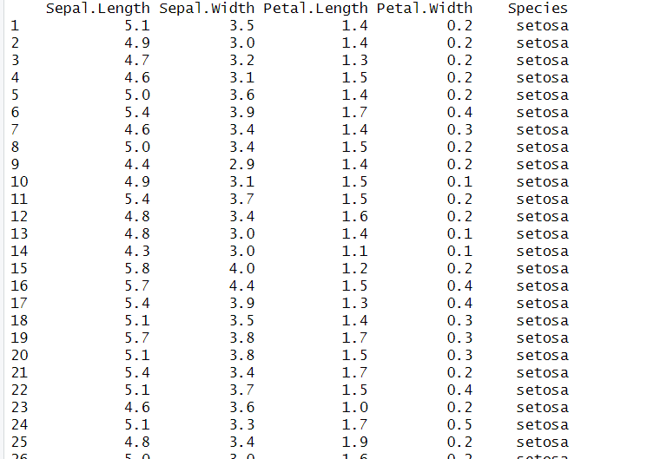

**load first 4 column of iris Dataset and print it**

> data <- iris[1:4]

> data

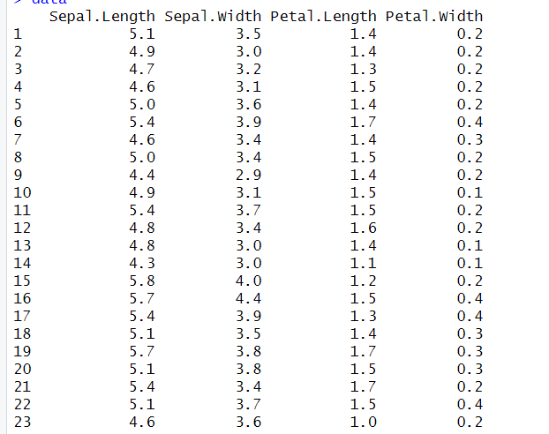

**Using princomp function for performing PCA**

> pc <-princomp(data,cor=TRUE,score=TRUE)

> pc

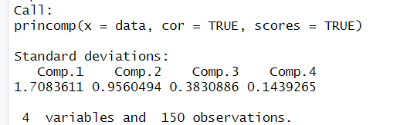

**Print Summary**

> summary(pc)

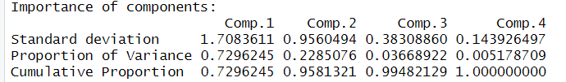

**Plot Graphically**

> plot(pc)

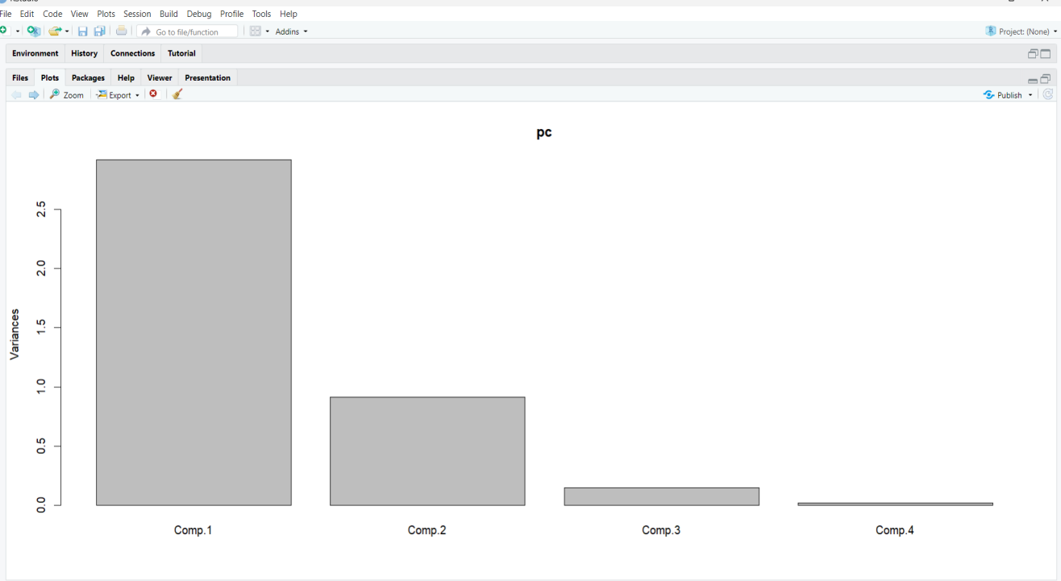

> plot(pc,type='l')

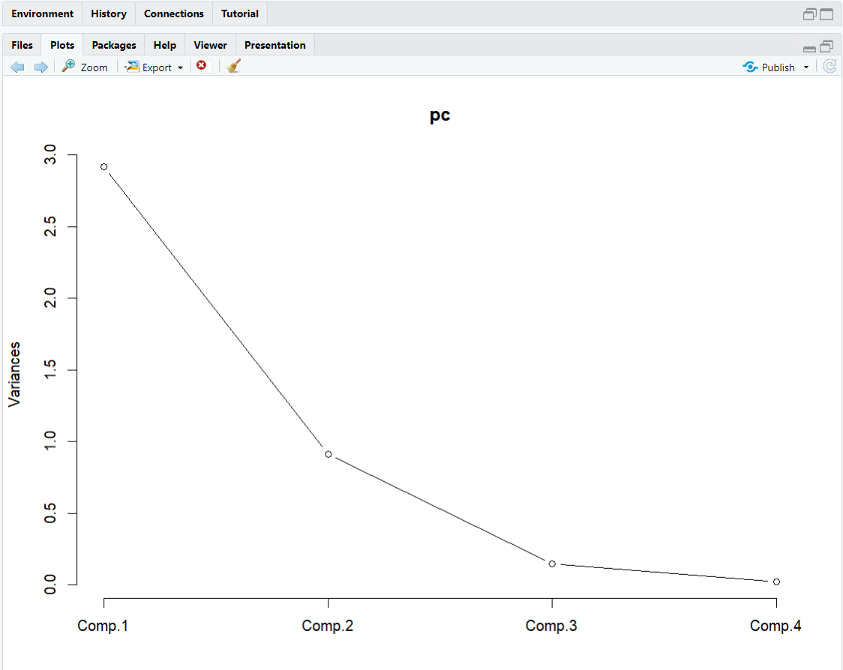

> biplot(pc)

